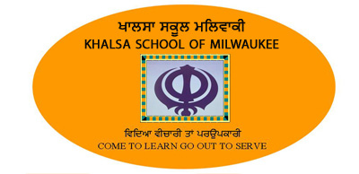
REGISTRATION FORM

Please fill the form completely
Return form with $ 50 fee /student/year
School starts in April every year.

STUDENT 1

Name: Middle Name: Last Name:

Tick One: New Student If Returning student Previous Panjabi Level: 1 2 3 4

Does your child understand Panjabi? Very Well Just a Little Not at all

What would you like your child to study? Punjabi Gurmat Rehat Maryada Kirtan Sikh History

STUDENT 2

Name: Middle Name: Last Name:

Tick One: New Student Returning student Previous Panjabi Level: 1 2 3 4

Does your child understand Panjabi? Very Well Just a Little Not at all

What would you like your child to study? Punjabi Gurmat Rehat Maryada Kirtan Sikh History

Parents

Name:

Address:

Home Phone: Cell: Email:

Please check how you would like to be contacted? Mail Phone Email

Emergency Contact Number:

PLEASE DONATE TO KHALSA SCHOOL ACCORDING YOUR SHARDA. IT WOULD BE GREATLY APPRECIATED BY STUDENTS AND SEWADARS. THANKS.

Sewadars.

